
WJ Art News

Quarter 2 2012

Questions? Comments. Concerns.
Email me at: agravlin@west-jefferson.k12.oh.us or Call me at: 614-879-7681
All work was returned to take home last week
Check out Artsonia.com
Dates to Remember:
Jan 10, 11, 12 Finals
Jan 12 last day of 2nd Quarter
Jan 13 &16 No school
Jan 17 New semester classes Begin
Jan 20 report cards go home
Feb 16 parent teacher conferences
Feb 17 & 20 no school
Feb 24 Empty Bowls Chili Fundraiser

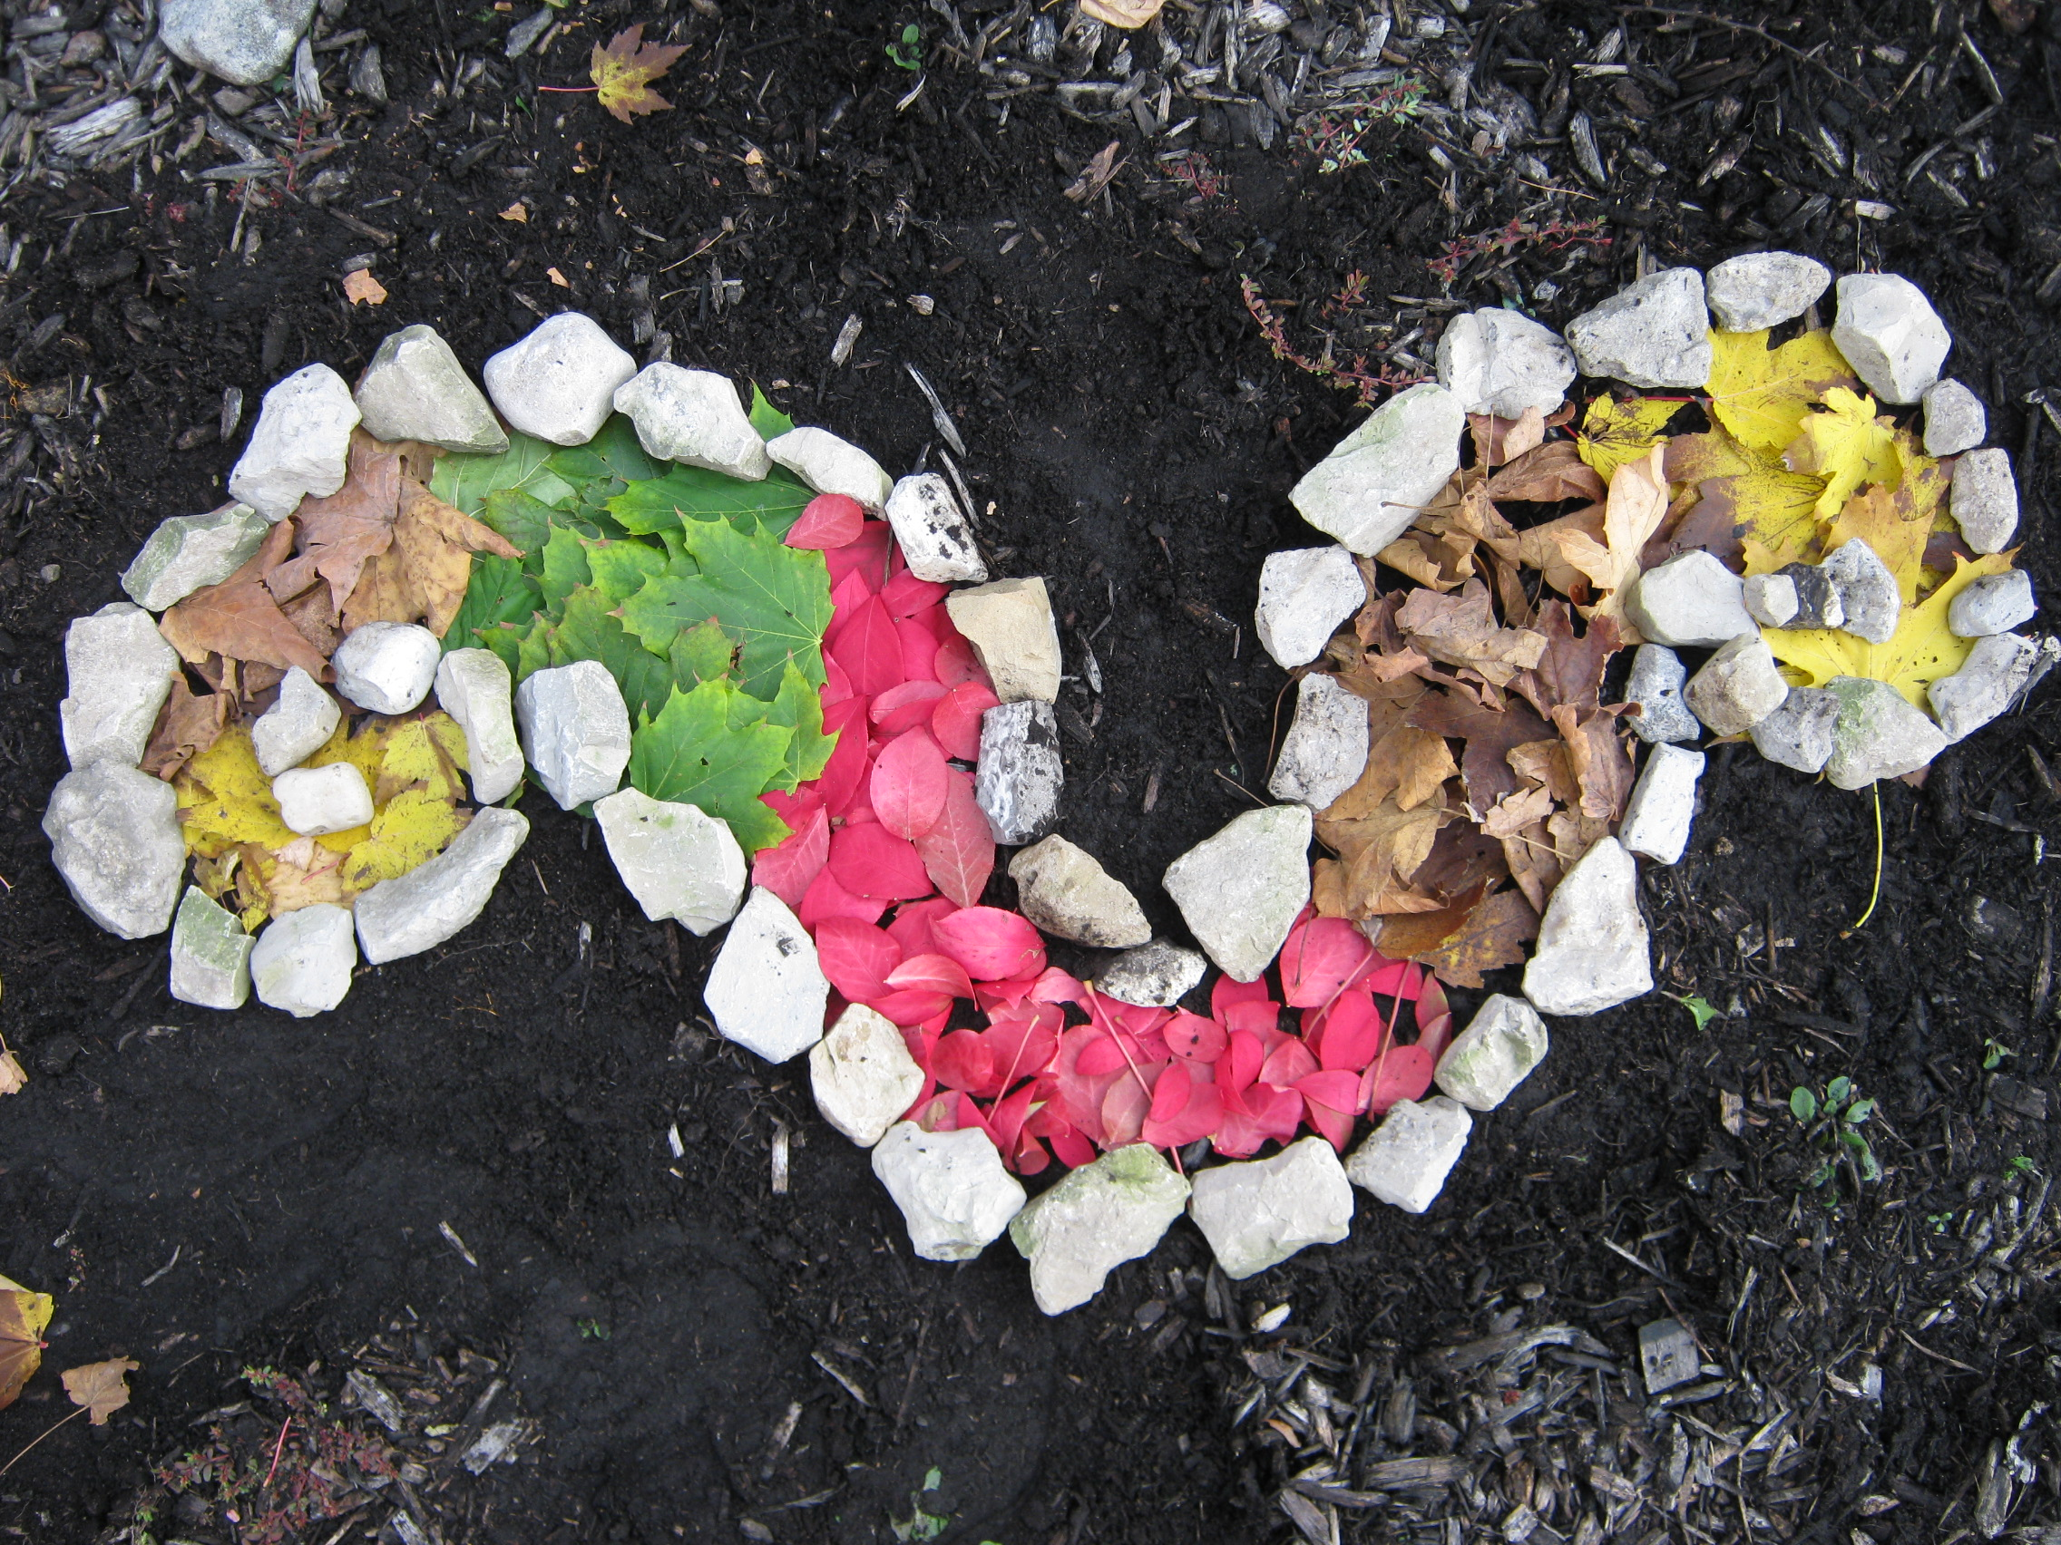

Concepts we have learned about….

Art 1
Completed final: Pocket still life in color schemes

If you can’t find your students work, ask them about it!
We are now working on wax resist.
Coming up: symmetry, Georgia O’Keeffe, perspective

Art 3
Portraits turned out great!
Check out Artsonia .com http://www.artsonia.com/schools/school.asp?id=100941

Ceramics
We have completed learning coils, slab, and pinch techniques. We are working on putting all those concepts together to complete larger vases. Greek vases, Egyptian canopic jars and free forms are in the works. The final will be a themed teapot. Plus they will get a chance to throw on the pottery wheel.

Art History
Final is online at:
http://quizstar.4teachers.org/

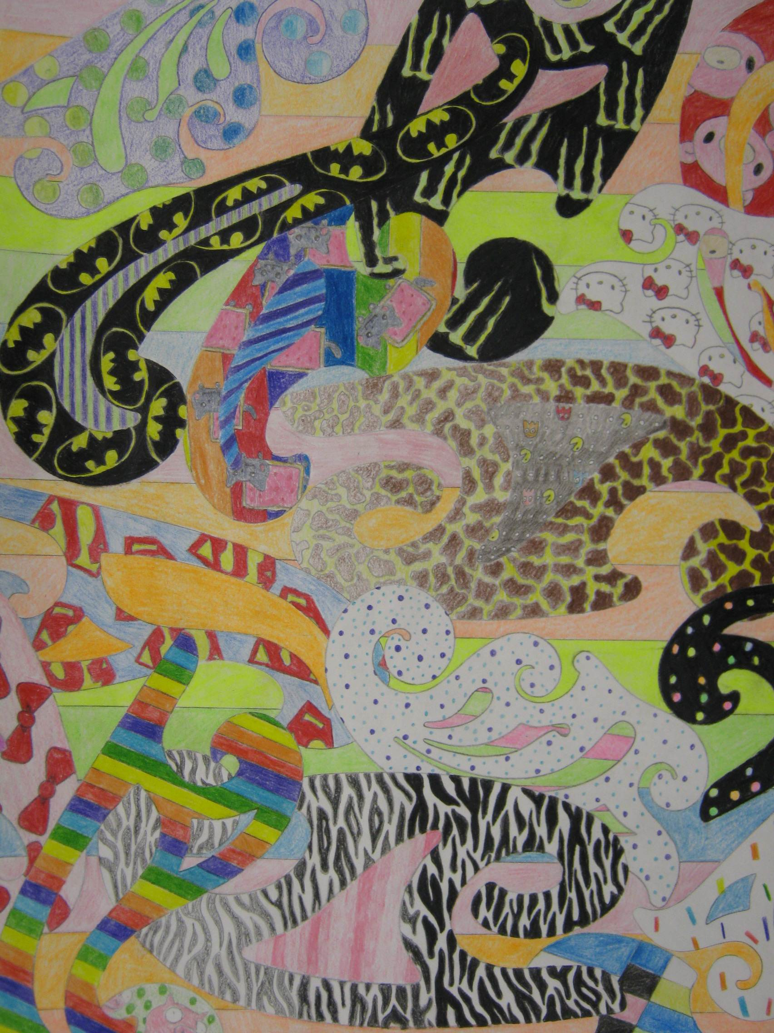
Digital Photo

All last minute work and Finals are due. http://wjdigitalphotographyclass.shutterfly.com/
Ask your student for the password.
We are working on speed, collections and photo essays soon.


